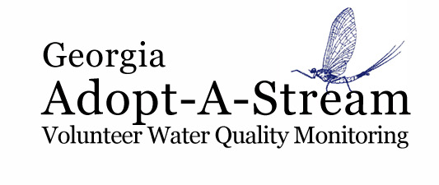

Adopt-A-Stream Poster Session

Abstract Submission Form

Selected entries will present posters at Confluence, the AAS volunteer conference on
March 22-24, 2019 at the Unicoi State Park & Lodge in Helen, GA.

Presenter Name(s): ____________________________ Date: ____________

Phone: _____________________ Email: __________________________

Is presenter under 18 years of age? Yes No

Preferred mailing address (list school address if under 18):

Address: _____________________________________________________

City: _______________________ State: ________ Zip: ____________

Entry Level*: ___________________
* Volunteer or Graduate, Undergraduate, High School (9th-12th Grade)

School, AAS Group, or other affiliation: _____________________

If applicable:
Advisor/ Teacher Name: ___________________________

Phone: _________________ Email: ______________________

Co-authors/project partners: ___________________________

Title: ________________________________________________________

Abstract (250 words or less, attach if necessary):

Please return this form via email by January 14, 2019 to: AAS@gaepd.org

For questions, contact 404-651-8512 or email to above

